Multispecies Occupancy Modeling – OR TWS

February 10, 2017

R Set Up Instructions

If you are not familiar with R, but would like to run some of the models discussed in the workshop follow the instructions below and you should be able to run the scripts provided.

1. **Download and save the necessary files**

You should have already downloaded the folder “ORTWS_OccModel.zip” from the dropbox. Extract the folders and save them in a convenient location on your computer. We will use the “In-Class Example” folder during the workshop.

1. **Download and install R, RStudio, and JAGS**

Download and install a current version of R from [https://ftp.osuosl.org/pub/cran/](https://ftp.osuosl.org/pub/cran/%20)

Download and install a current version of RStudio (free open source version) from <https://www.rstudio.com/products/rstudio-desktop/>

Download and install a current version of JAGS from <https://sourceforge.net/projects/mcmc-jags/files/JAGS/4.x/> (I suggest downloading “JAGS-4.2.0.exe”)

1. **Open RStudio and load the necessary packages**

Launch a new RStudio window. Select File -> Open File and navigate to the “In-Class Example” folder you just saved. Select the file “00_Rsetup.R” and click open. The script should open in a new script window RStudio.

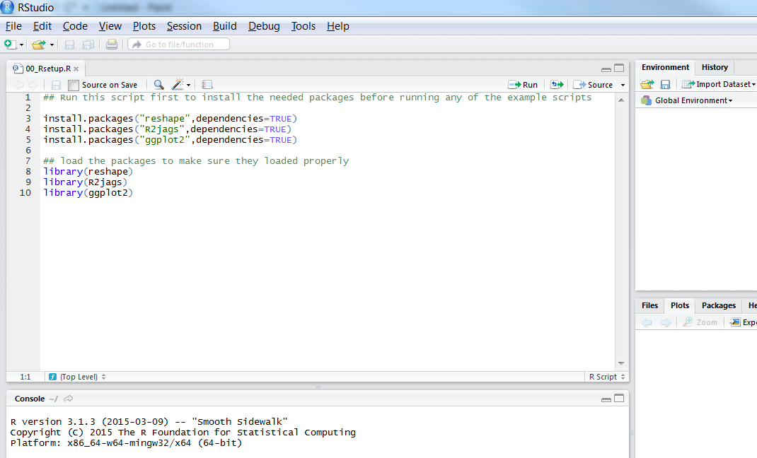

Now that the script is open, place your curser on “install.packages("reshape",dependencies=TRUE)” then click “Run” in the upper right. You should see some text pop up in the Console window below the script, something like but not necessarily identical to the example below.

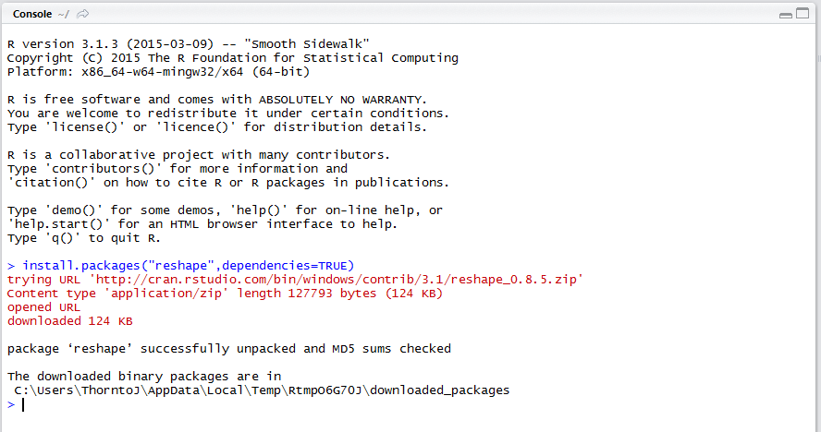

Once the first package has installed, run the next 2 lines of code to install the other packages.

To insure the packages have installed properly, run lines 8-10 (you can highlight all three and then click run). As long as there were no errors you should be ready for class.

**If you run into any trouble please come to class a little early so that we can help you get R set up before we start.**